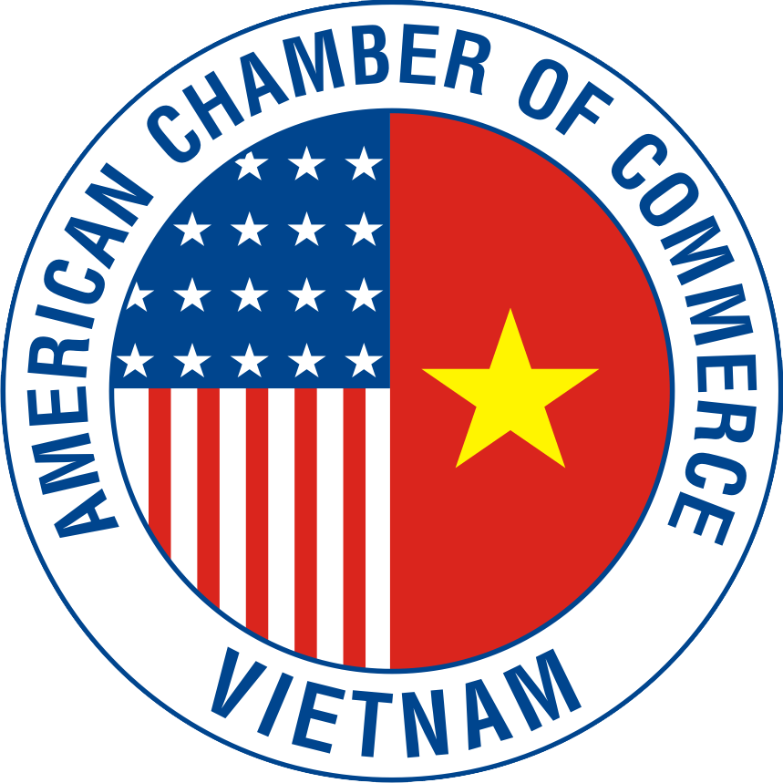
AMERICAN CHAMBER OF COMMERCE IN VIETNAM (AMCHAM)

POSITION PAPER AT THE ANNUAL VIETNAM BUSINESS FORUM 2017

Good morning and thank you for the opportunity to speak about AmCham’s perception of the business environment in Vietnam. This year, the American Chamber of Commerce celebrates 23 years serving as the “Voice of American Business” in Vietnam and our members remain committed to helping improve business conditions in order to strengthen the private sector and promote economic and social development here.

AmCham congratulates Vietnam on a successful year hosting APEC and we are confident that the rapid expansion of trade and investment relations between the US and Vietnam will continue and become dynamically stronger. Trade is the cornerstone of the US-Vietnam relationship and featured prominently in President Trump’s recent visit to Hanoi. During President Trump's meetings in Hanoi, the two countries pledged to deepen and expand bilateral trade and investment relations - in line with the President’s commitment to pursuing fair and reciprocal trade with key trading partners.

We see many American companies operating across the spectrum of economy activity here, including many efforts to help Vietnam become more productive, efficient, safe and cleaner. American companies have invested billions of dollars here, integrating Vietnam into the global supply chain, creating quality jobs for Vietnamese workers, and opening a new market for US goods and services.

President Trump’s State visit helped highlight the great opportunities available to American companies here. However, we often see investments that don’t materialize due to challenges dealing with corruption and an over-complicated, restricted, and unclear licensing and regulatory environment. Our members need greater reform efforts that help create a fairer and more competitive environment where decisions are made faster, procedures are less complicated, rules are fairly enforced, and companies compete on their merits - including for access to land and opportunities.

AmCham is pleased that the Comprehensive and Progressive Agreement for Trans Pacific Partnership (CPTPP) is moving forward and it is our hope that the United States will be able to participate in trade agreements in the future. Among other things, we support a path leading to a free trade agreement (FTA) between our two countries. For an FTA to move forward, it will need to be viewed as beneficial and fair by all parties. The American business community in Vietnam stands ready to do our part to make this goal a reality.

- Encouraging a Healthy and Safe Environment

Continued economic growth and the strengthening of the private sector creates opportunities for job creation, wealth creation and a better standard of living. With fair, uniform and transparent law enforcement, rapid development need not come with risks to the environment and well-being of citizens. Good decision making and new technology can enable Vietnam to tackle the already serious environmental concerns and avoid many more of the environmental problems that countries like the United States and China experienced during their high-growth phases.

Recent environmental concerns demonstrate the importance of understanding the links between business operations and society, and the importance of conducting business in a way that creates both long-term economic and social value. We believe in the rule-of-law and encourage the government of Vietnam to improve and enforce environmental regulations as the economy continues to grow.

- Building Sustainable Infrastructure

The quality of Vietnam’s operating environment and indeed the quality of life of its citizens rely on environmentally friendly and dependable infrastructure. With respect to power needs, there is a clear and urgent need to address the growing shortfall in the supply vs. the demand for electrical power and AmCham believes the Made in Vietnam energy plan of renewables, efficiencies, and gas provides a roadmap to closing the power shortfall in a manner that is sustainable from a financial, environmental and supply chain perspective with a focus of efficiencies, renewables and gas. Our member companies are global leaders in this sector and want to help ensure that Vietnam's energy development meets the environmental, health, economic and geopolitical security goals of the country.

We have seen good progress this year in efforts on renewable energy. However, to capture the billions of dollars in investment that Vietnam needs in this sector, we need a market-driven power pricing road map for the next five years.

The need for continued improvements to modernize and digitize the transport industry is increasingly important in Vietnam to catch up with the Industrial Revolution 4.0. More efficient transport and logistics can play a significant role in increasing productivity and better position Vietnam to benefit from global demand, serve domestic markets, attract investment and generate quality jobs. We hope that the government will judge new technologies, such as ridesharing services, based on their merit and ability to help solve development problems through advanced technology.

Quality infrastructure is expensive and it is clear that greater private sector participation is needed. Private investment often depends on government guarantees that in turn depend on a steady strengthening of the government’s balance sheet. This will require the continued divestment of state-owned enterprises that will not only provide the treasury with more cash, but also will allow the private sector to grow, stimulate capital markets and reduce corruption, as divested companies become more reliant on market forces and independent shareholder oversight. In addition, divestment will hopefully contribute to a more level playing field for everybody.

- Enforcing the Law in a Fair and Equal Manner

Whether a result of corruption, protectionism, tax collection, or the government trying to pick winners and losers, our members often see areas where inconsistencies, inefficiencies, and unfair practices persist - and in some cases new unfair practices are being enacted. We believe that it is vital that laws and rules be designed to be enforced fairly and equally. Better results in this area will improve the trust consumers have in the market place. It is also an important issue when considering ways to attract high-quality investment and strengthen the private sector here.

- Removal of Non-Tariff Trade Barriers

To sustain and grow our bilateral trade and investment relationship, trade must be free and fair. Importing products into Vietnam remains more costly and complicated then it should be, and, given Vietnam’s $32 billion trade surplus with the United States last year, it is particularly important for Vietnam to be seen as seriously addressing the numerous non-tariff technical barriers to trade mostly encountered at the border, and the so-called behind the border barriers which restrict the activities of companies and hamper the flow of US exports into Vietnam.

- Enable and Encourage the Private Sector

AmCham members remain optimistic about business prospects in Vietnam. However, we are concerned with recent changes in policy and regulations, which are not consistent with international best practices. These changes expose many foreign investors to considerable risks and obstacles in executing their investments.

For example, the current draft Cybersecurity Law is unique, because besides measures to protect cyber security, it also covers the control of Internet information, which is already regulated by other legislation. In addition, requirements in the draft Law that foreign service providers must locate their servers in Vietnam will not help improve Vietnam’s cyber security, and will create unnecessary burdens for foreign businesses.

The imposition of excise taxes on sweetened drinks is also an uncommon and ill-advised practice. Only four countries in the entire Asia-Pacific region, accounting for approximately two percent of the population in the region, impose excise taxes on sweetened beverages. Most countries do not impose this tax because it harms the economy and hasn’t been proven to protect heath. Meanwhile, the requirement on certification of announcement of conformity with food safety regulations in Decree 38/2012/ND-CP on guiding the implementation of the Law on Food Safety is highly disruptive to the operations of the food and beverage industry, resulting in higher costs while not bringing any value to food safety management.

As Vietnam seeks to provide better healthcare options for its citizens, we hope the government will commit to providing faster market access and reimbursement for innovative medicines. While Vietnam is doing well in terms of cost savings, slow access to innovative medicines for Vietnamese patients leads to key medical treatments being unavailable here. Only six percent of new molecules launched globally in the last 3-7 years are available in Vietnam. We recommend removing additional local clinical trials requirements for pharmaceuticals that already meet the highest global standards, and holding more frequent reviews of the Reimbursement List. This will reduce further outbound medical treatment. We note that Decree 54/2017/ND-CP guiding the implementation of the Law on Pharmacy includes provisions that are inconsistent with the Law and their enforcement would force some current foreign investors to close their fully licensed warehousing and transportation services -- causing a loss of hundreds of millions of dollars for the investors and a disruption of supply of thousands of life-saving medicines. AmCham believes current legislative revisions offer an opportunity to significantly increase investment in innovative drugs, vaccines, and other toll manufacturing.

AmCham is pleased that the State Bank of Vietnam (SBV) is carrying out research to amend and supplement some articles related to card payments as stipulated in Circular 19/2016/TT-NHNN regarding bank cards. We look forward to a dialogue with the SBV to address the key issues that have been consistently raised by US payment companies, banks and industry associations regarding the operations of a National Payment Gateway (NPG) and to ensure that the implementation of the Circular meets the goals of the government while not impeding the security, speed and reliability of the transactions, and will not unduly hinder the competitiveness of foreign payment companies. To achieve the government's goal of far greater use of non-cash payments, it is critical that Vietnam maintains a conducive environment that fosters competition between and among local and foreign players to promote innovation, better cybersecurity and more cost-effective solutions and products.

We also note that in implementing Vietnam’s new Civil Code, the SBV has issued new banking regulations that create significant challenges for foreign companies. Most recently, Circular 23/2014/TT-NHNN and Circular 32/2016/TT-NHNN no longer allows certain foreign agencies (e.g. representative offices, branches of foreign organizations, embassies, foreign investment funds, etc.) to directly open bank accounts in Vietnam. Again, we hope the government will look at these challenges as the private sector seeks initiatives that enable and facilitate rather than restrict business opportunities.

Another concern is Decree 181/2013/ND-CP guiding the implementation of the Law on Advertisement which requires a Vietnamese entity to only engage a locally licensed advertisement agency. This requirement not only exposes Vietnam to potential violations of the “national treatment” principle under their World Trade Organization accession agreement, but also restricts opportunities for small and medium enterprises (SMEs) from promoting their products and services domestically and internationally when they advertise their products and services on cross border platforms like Google or Facebook. With limited budgets for advertising and marketing, the Vietnamese SMEs find these platforms the easiest and most effective way to promote their products and services. Unlike large enterprises, these SMEs do not need and cannot afford the engagement of advertising agencies for their advertisement and marketing activities.

Given the importance the government places on attracting foreign investment, we look to work in partnership with the government and agencies to help resolve challenges and prevent problems. Our member companies are eager to share regulatory best practices when they are given sufficient time and opportunity to comment on proposed new rules.

- Modernizing Education and Ensuring Appropriate Labor Costs

The foundation for improving the operational efficiency and competitiveness of Vietnamese-based businesses is workforce productivity. Numerous studies show that educational curricula are outdated, teachers overwhelmed and underpaid, and graduates lack the job-ready skills sought by the private sector. To continue attracting investment and to upgrade the skills of its workforce, the government should take further action to modernize and upgrade its national education system, particularly at the vocational and university levels. Modernizing education will ensure that Vietnam has a skilled workforce of managers, engineers, and manufacturing technicians that can move up the value chain as the economy grows.

Workforce development initiatives will improve worker output, but efficiency also depends on one critically important input: labor costs. Over the years, the rises in wages and the costs of mandatory insurance schemes have simply not been matched by increases in productivity. The result is that many companies across Vietnam are experiencing declines in productivity for each dollar invested in human resources. This is simply not sustainable. A particular cost concern is the draft proposal by the Ministry of Labor that companies contribute 18% of foreign worker salaries into Vietnam’s social insurance fund. If enacted, this would introduce dramatic and destabilizing higher costs for many foreign invested businesses and is unjustified given the unlikelihood foreign employees will ever benefit from such contributions.

- Strengthening Travel and Tourism Potential

The Prime Minister wants tourism to represent 10 percent of Vietnam’s GDP and we agree that this goal is not only attainable, but is also good for job creation, wealth creation and development of the country. Tourism is an excellent example of the synergies between FDI, domestic enterprises and SMEs. AmCham is encouraged to learn that the government is advancing legislation to allow Vietnamese citizens who meet appropriate criteria to enter domestic casinos. This supports the goal of strengthening the domestic tourism industry. We encourage the government to ensure a level playing field for foreign invested projects currently operating casinos in Vietnam as it selects locations for piloting local gaming.

We also note that the fast growing hospitality, tourism and meetings (MICE) industries contribute significantly to Vietnam's GDP and create thousands of new jobs every year. Despite the fact that the tourism industry has been identified as a key industry heading Vietnam's national economic development, a coherent strategy and persuasive road map are missing. Vietnam has real potential to become a leading tourism, meetings and events destination in Asia, however a smart and appropriate set policies needs to be developed.

- Creating a more Attractive, Transparent and Stable Business Environment

As major investors here, American companies have an interest in Vietnam’s continued success. The issues raised above highlight our belief that the business climate can best be helped by actions that increase productivity and reduce the costs and risks of doing business in Vietnam. More importantly, decreasing the cost and complication of doing business will benefit Vietnamese-owned businesses, many of which are SME’s, and will spur entrepreneurship, which will, in turn, ensure Vietnam’s future competitiveness and growth. AmCham will continue to play a helpful and constructive role, not just to complain but to also work to identify and implement solutions, and to be a strong advocate for a better business environment and a stronger private sector in Vietnam.

I wish good health, happiness and success to the leaders, distinguished guests, and our members here today, and I thank you for this opportunity to address the Vietnam Business Forum.

